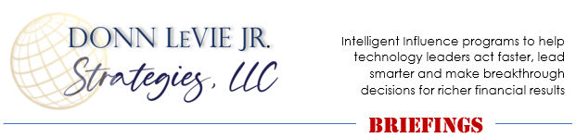
PERMISSION TO REPRINT ARTICLES FROM
DONN LeVIE JR. 24/7 EDITOR RESOURCE PAGE

Permission (non-exclusive) to reprint articles by Donn LeVie Jr. is hereby given to all print, broadcast and electronic media provided that the contact information at the end of each article is included in your publication. For organizations publishing articles electronically, a live, clickable link to https://www.donnleviejrstrategies.com must also be included with the body of the article.
Additionally, please mail one copy of your publication to:
Donn LeVie Jr. STRATEGIES, 6329 Clarion Drive, Austin, Texas 78749.
- Permission to reprint articles by Donn LeVie Jr. at no charge is granted with the agreement that:
  - The article bio be included following each article used.
  - One copy of the publication in which the article is published be provided to Donn LeVie Jr. STRATEGIES.
  - A $300 fee (per article) will be expected for articles published without the closing bio and contact information.
  - All articles © Copyright 2021 Donn LeVie Jr./Donn LeVie Jr. STRATEGIES, LLC.
- Permission is also granted for reasonable:
  - Editing content and industry-specific example exchange
  - Word length
  - Article title change
- Electronic publishing of articles must include a live, clickable link to https://www.donnleviejrstrategies.com.

Any questions, please email to donn@donnleviejrstrategies.com

Improve Weaknesses or Enhance Strengths?

What Managers and HR Get Wrong About Employee Performance Feedback
Why are major league baseball pitchers such terrible batters? Why are field goal kickers terrible receivers? Do batters put in much practice time in the batting cage? Do field goal kickers every run post patterns during practice?
Pitchers aren’t paid to hit; they are paid to strike out other batters. Field goal kickers aren’t paid to outrun a defensive back to catch a pass; they are paid to kick field goals. They work on their specialty that brings the most value to the team.
When I was managing teams of oil and gas professionals in the 1980s, I started wondering why the organization (and so many others) didn’t follow a similar line of reasoning with employee performance reviews. After years of drinking the Kool-Aid, I began asking: Why was so much focus directed toward working on deficiencies instead of enhancing inherent or learned strengths?
Left-brain analytical people were told to work on right-brain, creative shortcomings; right-brain creative thinkers were told to work on left-brain rational weaknesses. The differentiating expertise and skills that made them great performers were being sidelined in favor of suggestions (followed by training) that didn’t play to their strengths. The effect is heightened when intra-group “ranking and rating” occurs. Part of the problem (perhaps coming from HR and the training & development function) is when there’s pressure to focus on perceived employee shortcomings, weaknesses, and “vulnerabilities.”
Look at Figure 1, which illustrates the five key areas of talent development in organizations. It reads very much like a page out of the HR company handbook with an emphasis on internal skills development.
But the one thing that’s missing? A dogged, stubborn commitment on enhancing strengths that will expand the separation between the organization and its competition.
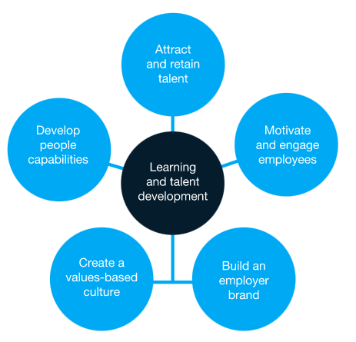

Figure 1. 5 Key Areas of Talent Development
When organizations provide employee performance feedback that has been normalized by a rank-and-rate approach for a business unit (team, department, division), what results when training for deficiencies is implemented is the creation of a unit of individuals with more or less uniform competencies.
“True differentiation — sustainable differentiation — is rarely a function of well-roundedness; it is typically a function of lopsidedness,” writes Youngme Moon in Different: Escaping the Competitive Herd. Moon also states that, “the same is true for excellence…excellence on any extreme almost always involves a trade-off…Negative tradeoffs are not only a marker of excellence, but they are also a marker of differentiation.”
What she means is that remarkable distinction is achieved not by working on weaknesses to bring them “up to par” but by driving the strengths to even greater
heights. I’m sure two-time Cy Young Award winner Randy Johnson and four-time Super Bowl MVP Award Winner Tom Brady would agree.
Figure 2a and 2b illustrate how most companies go about employee development based on performance feedback. Figure 2c illustrates Moon’s “lopsidedness” for developing sustainable differentiation.
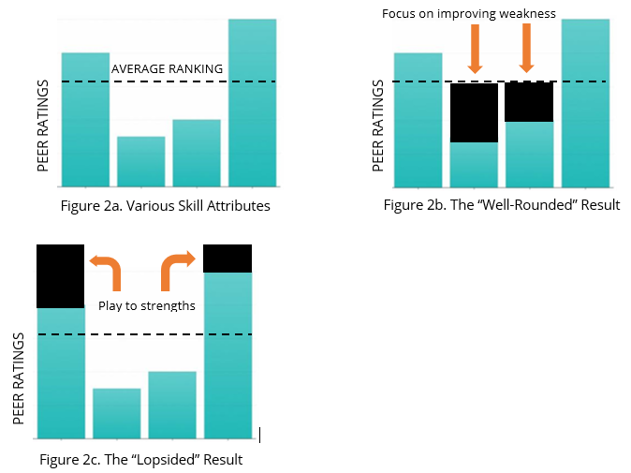
Admittedly, it may be difficult for organizations to discard the long-held well-rounded output approach, but it can quickly become a meaningless exercise if extending a competitive edge or market advantage is deemed the priority. Exceptional talent will produce exceptional results; nominal talent will produce, well, you know…

§§
Engagement and positioning strategist, leadership platform expeditor, author, and conference speaker Donn LeVie Jr. has 30 years’ experience leading people and projects for such Fortune 100 companies as Phillips Petroleum, Motorola, Intel Corporation; government agencies (NOAA), and academia (Department of Natural Sciences and Mathematics, University of Houston Downtown College). Donn specializes at the intersection of leadership, communication, and performance, which means he works with organization leaders and executives through the doorway of coaching and consulting. Contact Donn at donn@donnleviejrstrategies.com.

